*PROJECT DOCUMENTATION*

* *TEAM ID: NM2025TMID37030*
* *Project Title: Cookbook – Naan Mudhalvan Project*

*1. Introduction*

* *Team Leader:*

*Name: SANJANAASRI G*

*Email id:sanjuu200721@gmail.com*

* *Team Members:*

*Name: SANGEETHA H*

*Email id: sangeetharaika16@gmail.com*

*Name : SARANYA A*

*Email id: saranyavf2007@gmail.com*

*Name:SARANYA S*

*Email saranyasaranya52348@gmail.com*

*2. Project Overview*

* *Purpose:*

*The Cookbook project aims to provide a digital platform where users can discover, share, and organize recipes. It serves as an online repository of recipes categorized by cuisine, ingredients, and preparation methods, encouraging food enthusiasts to explore and learn.*

* *Features:*

* *User-friendly recipe posting and browsing*

* *Search and filter recipes by category/ingredients*

* *Recipe rating and review system*

* *Option to save recipes to favorites*

* *Admin control for recipe moderation*

*3. Architecture*

* *Frontend: React.js with HTML, CSS, and JavaScript*

* *Backend: Node.js with Express.js (for API and server-side logic)*

* *Database: MongoDB (to store recipes, users, reviews)*

*4. Setup Instructions*

*Prerequisites:*

* *Node.js*

* *MongoDB*

* *Git*

* *React.js*

* *Express.js*

* *Visual Studio Code*

* *Installation Steps:*

*Installation Steps:*

*# Clone the repository*

*git clone <repository-link>*

*# Install frontend dependencies*

*cd client*

*npm install*

*# Install backend dependencies*

*cd ../server*

*npm install*

*5. Folder Structure*

*RECIPE*

*│*

*├── node_modules*

*├── public*

*├── src*

*│   ├── components*

*│   │   ├── About.jsx*

*│   │   ├── CategoriesHome.jsx*

*│   │   ├── Footer.jsx*

*│   │   ├── Hero.jsx*

*│   │   ├── Navbar.jsx*

*│   │   └── NewsLetter.jsx*

*│   ├── images*

*│   ├── pages*

*│   │   ├── Category.jsx*

*│   │   ├── Home.jsx*

*│   │   └── Recipie.jsx*

*│   ├── styles*

*│   │   ├── About.css*

*│   │   ├── CategoriesHome.css*

*│   │   ├── CategoryPage.css*

*│   │   ├── Footer.css*

*│   │   ├── Hero.css*

*│   │   ├── Home.css*

*│   │   ├── Navbar.css*

*│   │   ├── NewsLetter.css*

*│   │   └── Recipie.css*

*│   ├── App.css*

*│   ├── App.js*

*│   ├── App.test.js*

*│   ├── index.css*

*│   ├── index.js*

*│   ├── logo.svg*

*│   ├── reportWebVitals.js*

*│   └── setupTests.js*

*├── .gitignore*

*├── package-lock.json*

*├── package.json*

*└── README.md*

*6. Running the Application*

* *Frontend:*

*cd client*

*npm start*

* *Backend:*

*cd server*

*npm start*

* *Access: Visit http://localhost:3000*

*7. API Documentation*

* *User:*

* */api/user/register*

* */api/user/login*

* *Recipes:*

* */api/recipes/create*

* */api/recipes/:id*

* */api/recipes/search*

* *Reviews:*

* */api/reviews/:recipeId*

*8. Authentication*

* *JWT-based authentication for secure login*

* *Middleware-protected routes for recipe creation and user favorites*

*9. User Interface*

* *Landing Page (explore recipes)*

* *Recipe Details Page*

* *User Dashboard (saved recipes, personal uploads)*

* *Admin Panel (recipe moderation)*

*10. Testing*

* *Manual testing during development phases*

* *Tools: Postman (API testing), Chrome Dev Tools (frontend debugging)*

*11. Screenshots or Demo*

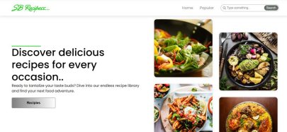 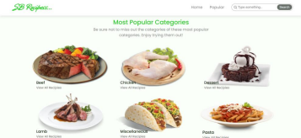 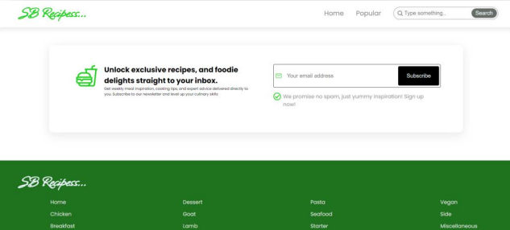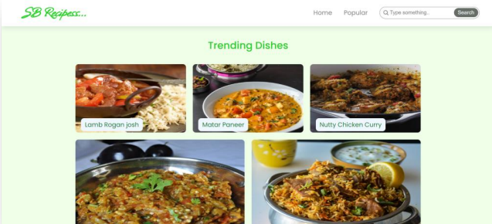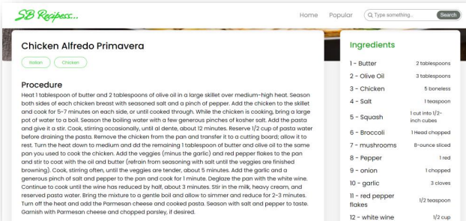

*12. Known Issues*

* *Search optimization can be improved*

* *Limited offline access*

*13. Future Enhancements*

* *AI-based recipe suggestions*

* *Nutrition calculator for recipes*

* *Multi-language support*